KAIROS OUTSIDE OF NEW MEXICO NEWSLETTER

DATE: April 2018 By: Lykala Williams

Dear Kairos Outside Sisters and Brothers:

Happy, 2018! This starts my 17th year of being God’s blessed servant in this ministry. It has changed my life and I am so grateful Darlene Reeves shared the ministry with me. I am extremely excited and honored (but a little scared ) to be serving as this year’s chairperson. We have some new challenges God is leading us to attempt in this year and beyond so we need “all hands on deck” and yes that means we need YOU
I have been in much prayer since I was elected on November 18th about how God would have me lead you. He has laid it on my heart to reach out to our members and RALLY all the help we can get to tackle our upcoming challenges. What are the challenges you may ask? We’re cooking, we’re on the move, and we’re in transition.
- Cooking! On weekend #31, for the first time ever in NM K/O, the men’s team will be cooking all the meals in addition to serving. WOW!
- Moving! We will be using Mt. View Camp in Ruidoso for #31 (April 2018) and Holy Cross in Las Cruces for #32 (2019). This is after using Lone Tree in 2016 and Black River in 2017. WOW!-four different venues in four years!
- A) Transitioning! We have a one-year “transition” chairperson-ME! After having the same chairperson for the last 3 years (I think) I will be a short-timer. Ellen Cady has led us with much grace and wisdom. Thank you Ellen!
B) An additional transition we hope to make is going back to two weekends a year. NM K/O Advisory Council believes God is leading us to get “back to two”. That’s my new motto. BACK TO TWO, BACK TO TWO, BACK TO TWO!! Please be in prayer about God’s direction and our discernment in this area.

My prayer is that as a member of this ministry you would continue, begin, or get back to offering your talents to help. We need leaders, fundraisers, crafters, cleaners, movers, shakers, lifters, doers, prayer warriors, weekend angles, council members, etc… Basically, God needs you involved. God needs you sharing this ministry to keep it alive. God’s Kairos ministry has changed so many lives and will continue to do so. What are you doing to help?
Jesus asked Peter, “Do you love Me?” If your answer, like Peter's, is “Yes, Lord,” Then you will do as he commands. In John 14: 12-15 Jesus says 12 Very truly I tell you, whoever believes in me will do the works I have been doing, and they will do even greater things than these, because I am going to the Father. 13 And I will do whatever you ask in my name, so that the Father may be glorified in the Son. 14 You may ask me for anything in my name, and I will do it. 15 “If you love me, keep my commands.
Please, if you’re not involved, get involved. If you are involved, “thank you and let’s do GREATER things like Jesus commands”.

YAY GOD!!

Paula Wallace, Chairperson
NM Kairos Outside
Kairos: Call to Closings & Reunions
Closing—Please make time to attend the Weekend Closing on April 29th at Mt. View Camp in Ruidoso. Please arrive at 1:30pm. You can reach out to past guests and encourage them to attend also. Your attendance really blesses the Guests and team members.

Reunions—Our reunions are an opportunity to spend time together in loving memory of our special weekends, past and present. It is also a good time to fellowship with each other since we rarely get to do that as a whole. After the reunion, we also have an open council meeting that we encourage all to attend. Our next reunion will be held in Las Cruces, NM, Living Waters Assembly Church, 900 Bowman.

Paula Wallace

Kairos Outside #30
April 28-30, 2017
Lynette Wood, Leader

I cannot believe that it’s has been a year since KO#30. As I remember back on that weekend, it’s as if it were yesterday. I’m still in awe at the way God worked through that weekend with the men and women who served on the team. From the very first team meeting I knew God was putting together a team that would exceed all expectations. I knew this because at every team meeting it was never about them, they focused on God and our Guest that would be coming.

As if reflect back, I think of the spiritual directors as they prayed over the team and brought thoughtful and meaningful devotions. The table leader and support ladies were on top of serving each guest, our facility director kept things moving smoothly as we went from place to place, the music team kept us praising God as well as laughing and having fun as we worshipped together. The women who were chosen to share their stories were sincere and honest, heartfelt, with many cleansing tears flowing. The agape that the ladies received were gifts of love, and the hard work it took to get it organized was outstanding. Those who stepped up and helped with agape, thank you. I don’t have the right words of appreciation for the kitchen team. From decorations to skits to the banquet, they never let up. This brings me to my OL 1 Linda, and OL2 Lena, and Connie, Observing Leader, I could not have accomplished any of the weekend without them, and their support, prayers and encouragement. I know the 18 guest who attended could see and feel the love of God and the love we all had for them. Please stay in touch with your contacts, bring them in as team members to serve on a weekend. They are Kairos future!

As I close, remember “For we are God’s masterpiece. He has created us anew in Christ Jesus so that we can do good things He planned for us long ago. Ephesians 2:10 (NLT)

Who Are WE – WE are His
God Bless each of you
See you at the closing for KO 31.

Lynette Wood

WHEN: MAY 12, 2018

WHERE: Living Waters Church
900 Bowman
Las Cruces, NM

TIME: 10:00 A.M. – 2:00 P.M.

Breakfast and Lunch will be
provided.

Please join us for our Kairos family Reunion on May 12. This is a special time to renew Friendships and strengthen new Friendships. There will be Great Food – Fun – Fellowship. Spouses and children Welcome!

It’s fun to car pool if you live Outside of Las Cruces. Check your current and past Guest and Team list in your going forth packet for anyone living in your area.

SEE YOU MAY 12!!!!

Message from:
Connie Baker
International Representative for
NM State Advisory Council

Hi All.

I am the International Representative for the NM State Advisory Council. This is my first year so I am excited to get to go to my first conference for my new position. It is going to be held at Hyatt Regency Dulles in Herndon, Virginia which is located at the Washington Dulles International Airport on July 24-28, 2018. I fully expect to be overwhelmed with the meeting but look forward to sharing what I learn with our NM Advisory Councils.

Also, I am the Chairperson for a committee for the NM State Advisory Council. We are going to have a Volunteer Retreat for anyone interested in learning more about the various Kairos Prison Ministries here in New Mexico. I am looking for anyone who would be interested in joining this committee or if you have any suggestions. We are planning the event for September 7th-8th at a place to be determined. Evelyn Lemly from KPMI, Inc. is going to fly in to give us some information and also contact Wardens, DOC, Chaplains, and/or anyone else that would be beneficial. If anyone has any suggestions or would like to assist in this, email me at conniebaker1301971@yahoo.com. I hope to have a large turnout and that it will be something we can do each year. Thanks! In His Service, Connie Baker

Kairos Outside #31
April 27-29, 2018
Linda Boyd, Leader

To my Dear Kairos brothers and sisters,

This has been an amazing 2 years preparing to be the leader of Kairos #31. Last year I began asking potential team members to join me in serving on Kairos #31. I have talked to so many people and am confident that this is the team God has put together. I am trusting in God to make this weekend be fully what he has planned. There have been bumps and a few life problems but God has prevailed and this weekend will be successful.

The scripture and shield I have chosen is Isaiah 61:10. I delight greatly in the Lord. My soul rejoices in my God. For he has clothed me with garments of salvation and arrayed me in his robe of righteousness. This scripture portrays my life and Gods favor on it. The shield was drawn by Emillia Ojeda. The shield fits perfect with the scripture. Again Gods plan. My colors for the weekend are purple, black and gold. I also selected crosses to brought to the weekend for the chapel decorations. I have been praying for the team and the guest who will be attending. It feels so amazing to be a part of Gods ministry. I am honored to serve on this team of women and men who love God and put him first in their lives. Please pray for this weekend and the guest who God will bring.

God is Faithful,
Linda Boyd, Leader
KO #31, April 27-29, 2018
Things to remember:
Kairos #31, April 27-29, 2018.
Closing for #31, Apr. 29, 2018 arrive by 1:30pm.
Kairos Reunion, May 12, 2018, 10:00am to 2:00pm. Living Waters Assembly, 900 Bowman, Las Cruces, NM.

Don’t for get to ask others for agape, purchase meal tickets, a nights stay, “green agape”.

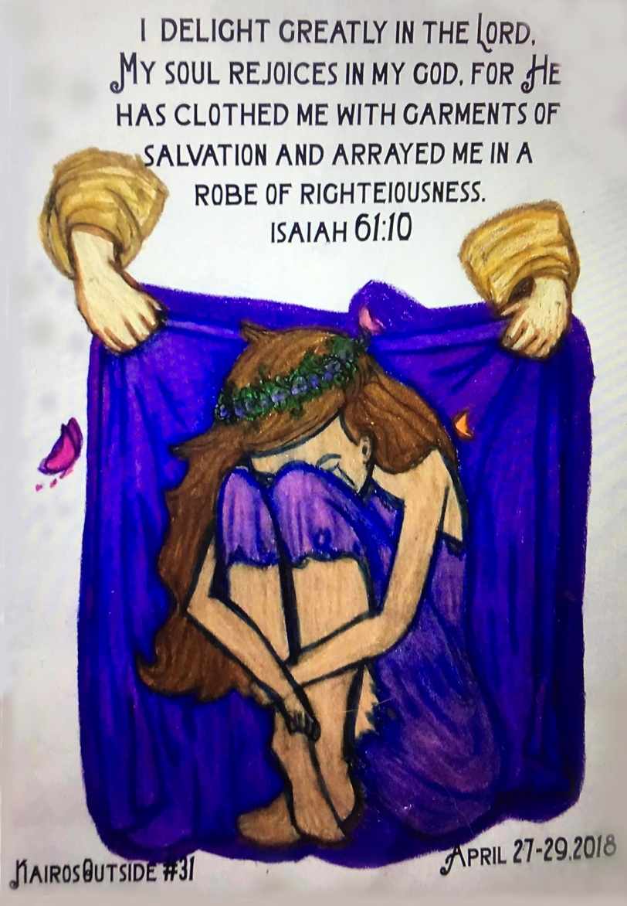

Word of Encouragement

Look for His Likeness
He will keep his agreement of love for a thousand lifetimes for people who love Him and obey His commands. Deuteronomy 7:9

We are God’s idea. We are His. His face. His eyes. His hands. His touch. We are Him. Look deeply into the face of every human being on earth, and you will see his likeness. Though some appear to be distant relatives, they are not. God has no cousins, only children.
We are incredibly, the body of Christ. And though we may not act like our Father, there is no greater than this: We are His. Unalterably. He
Loves us. Undyingly. Nothing can separate us from the love of Christ.
A Gentle Thunder by
Max Lucado

